INVESTIGATION REQUEST (IR)
IT Reference Number:
SECTION 1: REQUESTOR INFORMATION & APPROVAL
(Request will be rejected without the HOD / Manager / Assistant Manager approval signature)
User Name: | Vins Sarvindran | Staff ID: |  |  | A140223
Department /Branch: | PFBG – Product Development | Extension: |  |  | 8095
Email Address: | sarvindran@aeonmalaysia.com.my | Date /Time: |  |  | 13 Jan 2014
Approved By: | Kelvin Chin Kim Leong
Signature: |  | Date /Time: |  |  | 13 Jan 2014
SECTION 2: REQUEST DETAILS
(Please attach with detail Supporting Documents, if any)
Application: | Credit Card EP System WEB Appl. ATM Others. Please state:
Environment: | Production User Acceptance Test
Request Description:

Kindly refer to the attachment I (Additional requirements)

SECTION 3: IT USE ONLY
Assigned To: |  |  | Date /Time:
Priority: | Stopper /Critical High Medium Low
Request Classification: | Program Error Clarification ACR Environment Authority Query User Error
Status: | Fixed/Completed Dropped Rejected  Management Decision KIV |  | Completion Date /Time:
Comments:

Reviewed By:
Signature: |  | Date /Time:
Approved By (HOD or designate):
Signature: |  | Date /Time:
SECTION 4: USER ACCEPTANCE
Tested By: |  | Status: |  | Failed Successful
Accepted By:
Signature: |  | Date /Time:
Remarks (if any):

Attachment I
- To extract customer loan data (PF product) from AS400 for creation of PF statement.
- Data to be extracted includes active ac, closed ac for the statement period (early settle, ac mature).
- Necessary customer’s loan data is to be exported into the prepared PF statement template. (Kindly refer to attachment I).
- Mandatory loan data to be incorporated into the PF statement template as follows;
- Customer name
- Customer mailing address
- Account opened date
- Account no.
- Statement year
- Financed Amount
- Total profit
- Tenure (months)
- Amount Opening Balance as at 01st January
- Total debit amount
- Total credit amount
- Amount closing balance as at 31th December.
- Transaction date
- Transaction description
- Amount debited per transaction
- Amount credited per transaction
- Balance Amount
- Extraction data for active ac shall include all active PF acct as at 31st Dec 2013.
- Extraction data for closed ac should include closed acct due to pay in full or early payment which dated 1st January 2013 up to 31st December 2013.

Additional requirements

- Add 1 more line in the table before the last line to show ‘Rebate’ that customer entitle for early settlement.

- Change the description ‘delete payment’ to ‘Reversal Payment’.

- Change the description ‘Early Payment transaction’ to ‘Early Settlement’.

- Opening Balance as at 23 Jan 2013.

- Please refer to Appendix 1 for references.

Appendix 1

i.e.:
Date/Tarikh | Description/Butir-butir | Debit / Debit (RM) | Credit / Kredit (RM) | Balance / Baki (RM)
date (xx/xx/xxxx) | Rebate | - | RM xx.xx | xx.xx
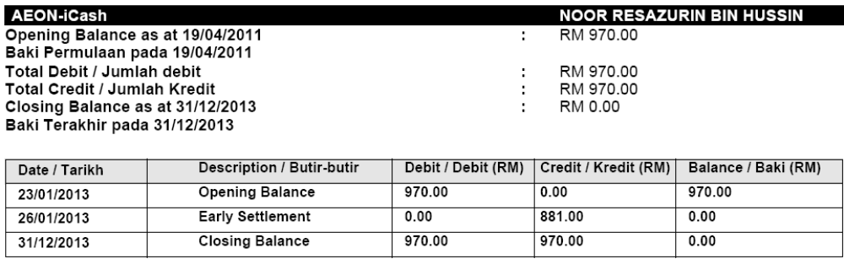
Opening balance as at 23/01/2013

